EXP 14 : MATLAB SIMULATION OF PASSBAND TRANSMISSION WITH BER ANALYSIS UNDER MULTIPATH FADING CHANNELS

SOFTWARE USED : MATLAB SOFTWARE

CODE ;
clc; clear; close all

N=10000; SNR=0:5:20;
bits=randi([0 1],N,1);
x=2*bits-1;
h=[0.9 0.4 0.2];
ber=zeros(size(SNR));

for k=1:length(SNR)
rx=filter(h,1,x);
rx=awgn(rx,SNR(k),'measured');
d=rx(1:N)>0;
ber(k)=mean(bits~=d);
end

subplot(2,1,1)
plot(SNR,ber,'o-'),grid on
title('BER under Multipath Fading')
xlabel('SNR (dB)'),ylabel('BER')

subplot(2,1,2)
plot(rx(1:200)),grid on
title('Received Signal')
xlabel('Sample'),ylabel('Amplitude')

disp(table(SNR',ber','VariableNames',{'SNR_dB','BER'}))

MODEL GRAPH :
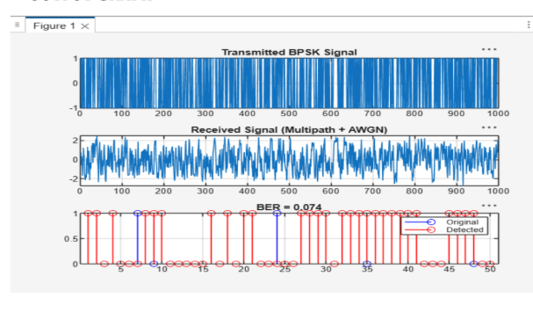
RESULT :
